**ASSIGNMENT - 5**

**Name: Shameer Shaik**

**Student ID: - 7007405840**

**CRN: 21627**

**GitHub link:** [**https://github.com/SHAMEERSHAIK7/Machine-Learning-CS-5710**](https://github.com/SHAMEERSHAIK7/Machine-Learning-CS-5710)

**Video link:** [**https://vimeo.com/817155884/4e7f0eda30**](https://vimeo.com/817155884/4e7f0eda30)

**1)**

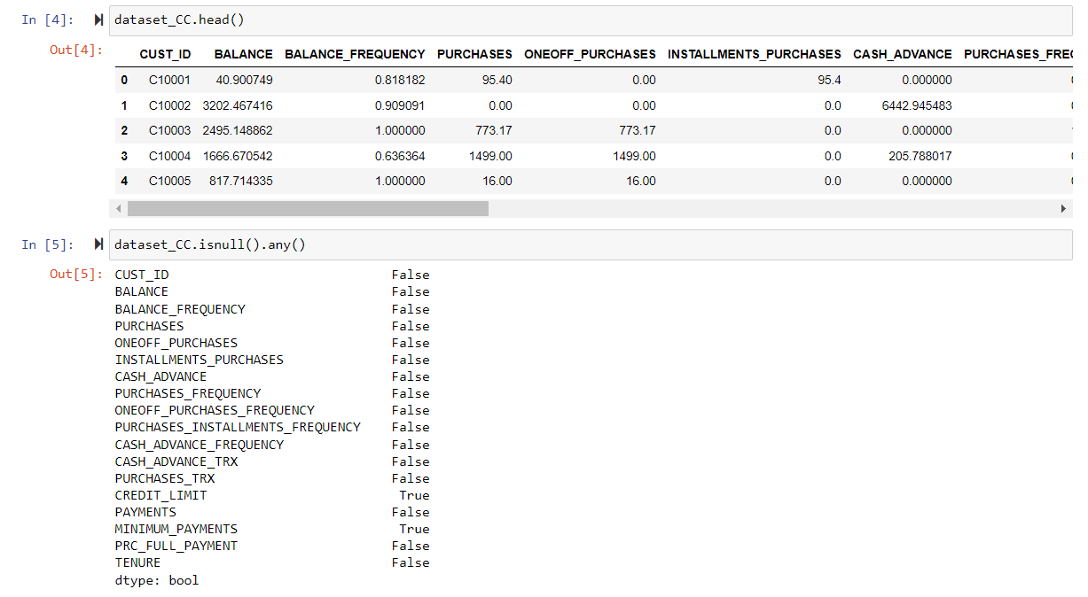

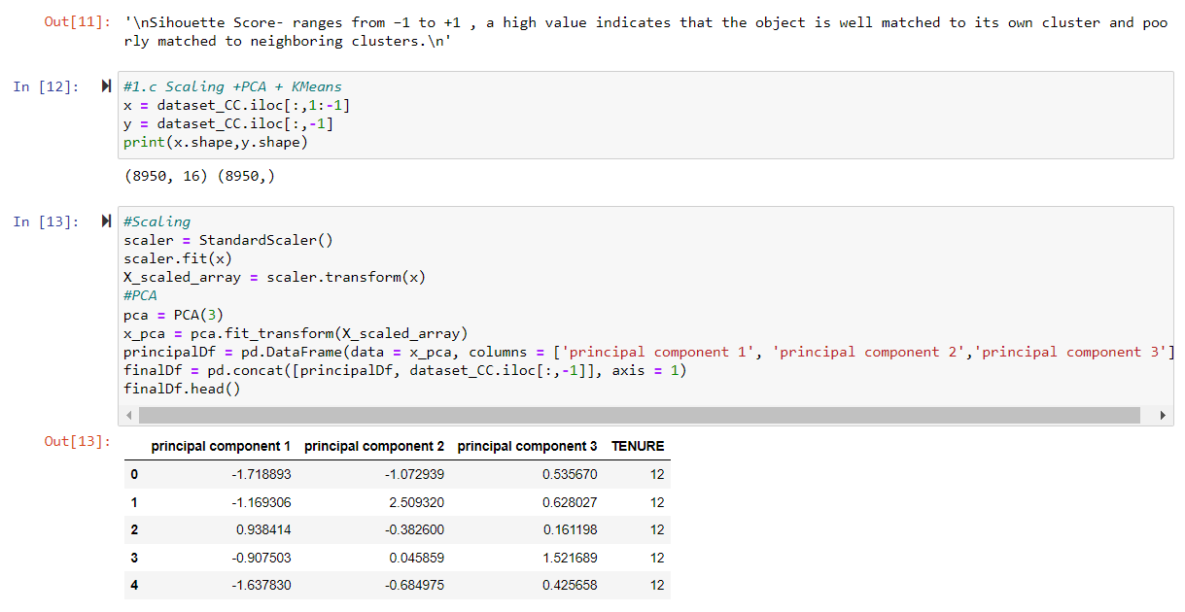

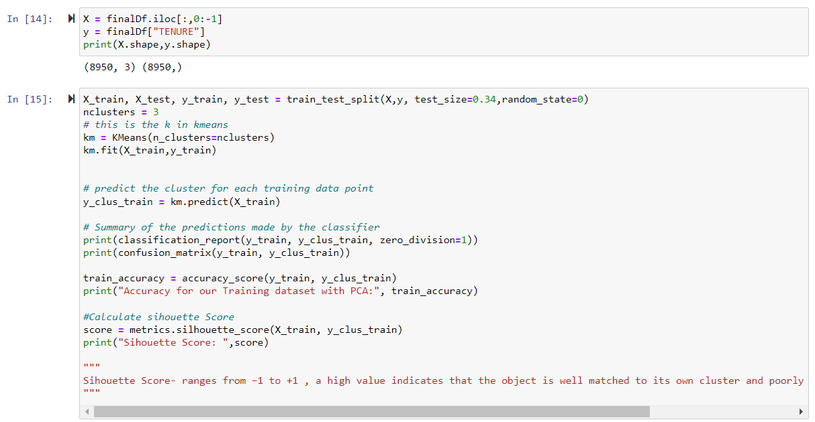

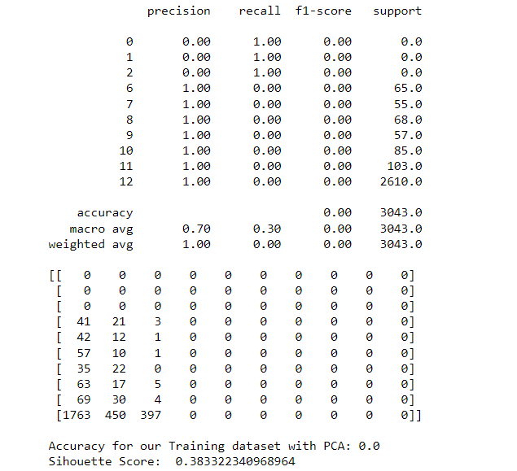



**2)**

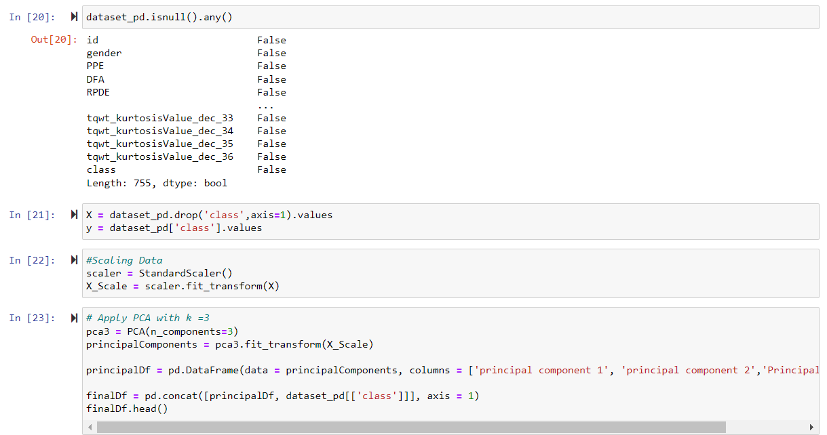

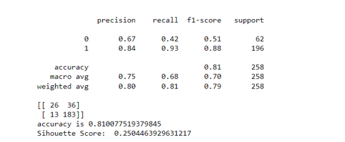

**3)**

**4)**

"The goals of LDA and PCA are the same: to maximize variance in a lower dimension via linear transformations. Unlike LDA, which uses supervised learning, PCA uses unsupervised learning. Accordingly, LDA identifies pathways of maximum class separability while PCA finds directions of maximum variance regardless of class labels.

Principal components, which are linear fusions of the original variables, are used to condense the characteristics into a more manageable group of orthogonal variables. The data's greatest variability is captured by the first component, followed by the second and third, and so on.

To "maximize the variance between the different categories while minimizing the variance within the class," LDA "finds the linear discriminants."